*IteratorPatternDemo*, our demo class will use *NamesRepository*, a concrete class implementation to print a *Names* stored as a collection in *NamesRepository*.

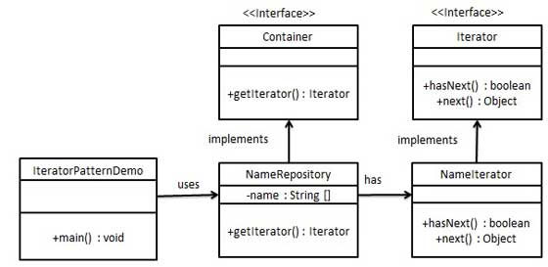

## Step 1

Turn this into a refrigerator

Create interfaces.

*Iterator.java*

public interface Iterator {  
 public boolean hasNext();  
 public Object next();  
}

*Container.java*

public interface Container {  
 public Iterator getIterator();  
}

## Step 2

Create concrete class implementing the *Container* interface. This class has inner class *NameIterator* implementing the *Iterator* interface.

*NameRepository.java*

public class NameRepository implements Container {  
 public String names[] = {"Robert" , "John" ,"Julie" , "Lora"};  
  
 @Override  
 public Iterator getIterator() {  
 return new NameIterator();  
 }  
  
 private class NameIterator implements Iterator {  
  
 int index;  
  
 @Override  
 public boolean hasNext() {  
   
 if(index < names.length){  
 return true;  
 }  
 return false;  
 }  
  
 @Override  
 public Object next() {  
   
 if(this.hasNext()){  
 return names[index++];  
 }  
 return null;  
 }   
 }  
}

## Step 3

Use the *NameRepository* to get iterator and print names.

*IteratorPatternDemo.java*

public class IteratorPatternDemo {  
   
 public static void main(String[] args) {  
 NameRepository namesRepository = new NameRepository();  
  
 for(Iterator iter = namesRepository.getIterator(); iter.hasNext();){  
 String name = (String)iter.next();  
 System.out.println("Name : " + name);  
 }   
 }  
}

## Step 4

Verify the output.

Name : Robert  
Name : John  
Name : Julie  
Name : Lora